**LOGO IDEAS**

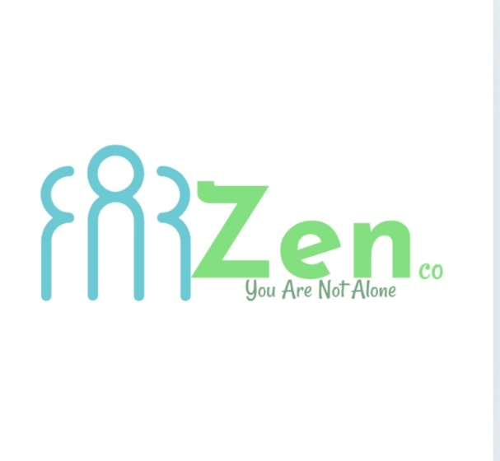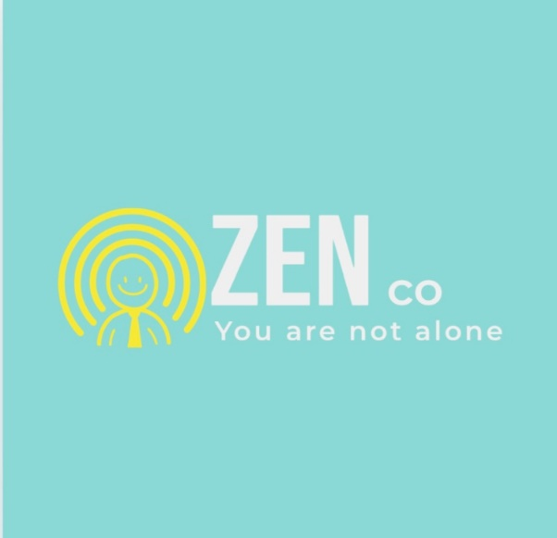

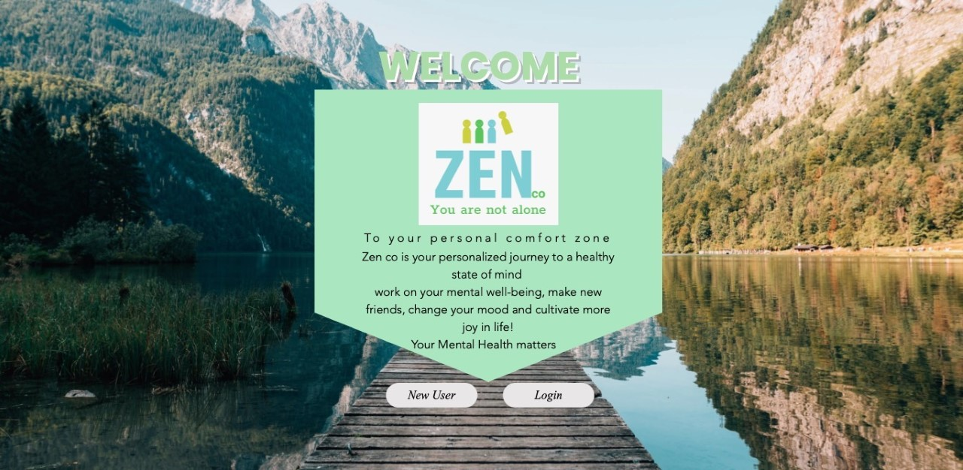

**WEB PAGE IDEAS**

* I created these two examples through using WIX website builder
* I created the logo using WIX logo
* The background image, text boxes, components are from wix

**Idea of the logo**

Colours – certain colours like blue and green are thought to have soothing effects on people who are stressed or anxious.

The Name – zen is a term that describes a feeling of peace and oneness. It’s also a type of meditation on how we should look at our inner selves with openness and acceptance rather than judgement

Background image – mountains symbolise peace and the person in the image finally attaining that peace, the idea of this image was to encourage the individual to find peace in themselves in regards to their depression and anxiety.

**FEEDBACK**

* The image can give off the idea of a ‘ travel website ‘ than a mental health one.
* The logo icon in the web design images should change as it looks like one of them are separated
* Social media icons don’t make sense.